Chapter Four

This chapter present the Data that was collected

The sample consisted of 110 respondents and 50.9% were Male and 49.1% were female

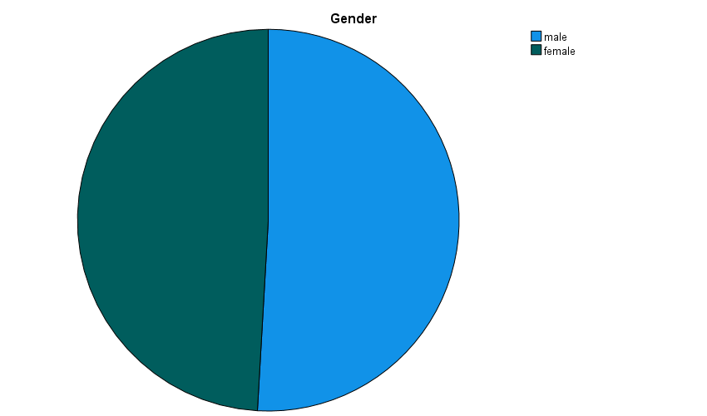

Age below 20 was 14.5%, 20-29 was 67.3%. 30-39 was 8.2%, 40-49 was 6.4% and 50 years and above was 3.6%. majority of our respondents aged from 20-29 years

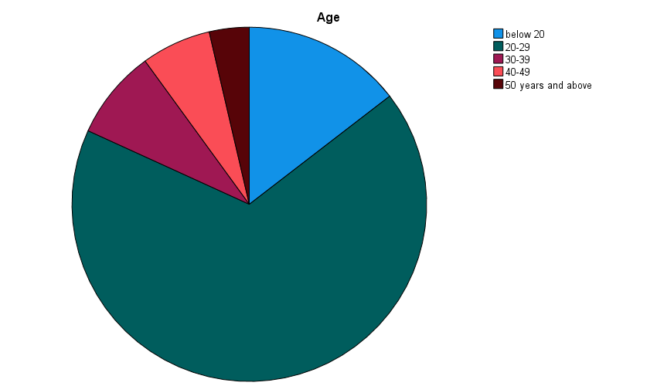

Education Level: Diploma level were 36.4%, Bachelor degree level 52.7%, Masters level were 6.4%, PHD 2.7%. others 1.8% therefore Bachelor degree level were the majority of respondents from this study.

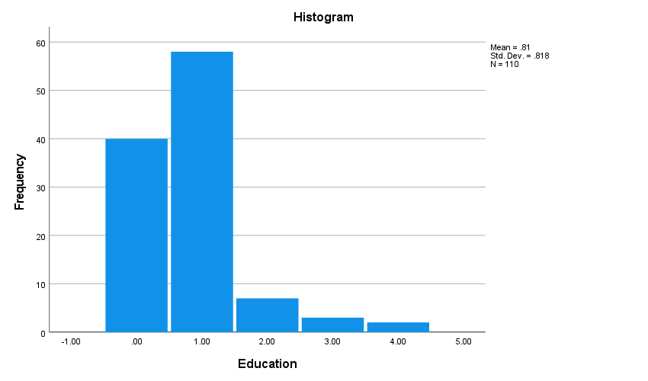

Respondents were asked about their work experiences 41.8% had less than 1year experience, 38.2% had worked for 2-5 years. 7.3% have experience of 5-10 years. 7.3% had 10-15 years of work experience, 3.6 % had 15-20 years of work experience and 5.5% had 20+ years of work experience.

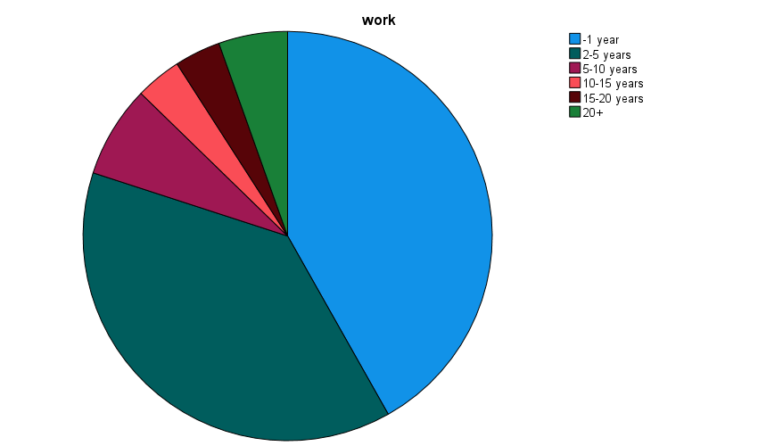

STAKEHOLDER INVOLVEMENT IN PARTICIPATOTY MONITORING AND EVALUATION

Respondents were asked If they were aware of any PM&E Systems at the Nairobi city county office, 48.2% responses were Yes, 50.9% replies were No,

|  |  |  |  |  |
| --- | --- | --- | --- | --- |
|  | | | | |
|  | | Are you aware of any PM&E Systems at the Nairobi city county office, | how frequently do you use the PM&E Systems in Project management | how would you describe the way you interact with the PM&E System at work |
| N | Valid | 110 | 110 | 110 |
| Missing | 0 | 0 | 0 |
| Mean | | .6000 | 1.3000 | 2.0545 |
| Median | | 1.0000 | 1.0000 | 2.0000 |
| Mode | | 1.00 | 1.00 | 1.00 |
| Std. Deviation | | 1.03339 | 1.12967 | 1.43889 |
| Variance | | 1.068 | 1.276 | 2.070 |
| Range | | 10.00 | 4.00 | 4.00 |
| Sum | | 66.00 | 143.00 | 226.00 |

|  |  |  |  |  |  |
| --- | --- | --- | --- | --- | --- |
| **Are you aware of any PM&E Systems at the Nairobi city county office** | | | | | |
|  | | Frequency | Percent | Valid Percent | Cumulative Percent |
| Valid | Yes | 53 | 48.2 | 48.2 | 48.2 |
| No | 56 | 50.9 | 50.9 | 99.1 |
| 10.00 | 1 | .9 | .9 | 100.0 |
| Total | 110 | 100.0 | 100.0 |  |

|  |  |  |  |  |  |
| --- | --- | --- | --- | --- | --- |
| **how frequently do you use the PM&E Systems in Project management** | | | | | |
|  | | Frequency | Percent | Valid Percent | Cumulative Percent |
| Valid | Monthly | 29 | 26.4 | 26.4 | 26.4 |
| Quarterly | 46 | 41.8 | 41.8 | 68.2 |
| Yearly | 10 | 9.1 | 9.1 | 77.3 |
| as per project requirement | 23 | 20.9 | 20.9 | 98.2 |
| 4.00 | 2 | 1.8 | 1.8 | 100.0 |
| Total | 110 | 100.0 | 100.0 |  |

|  |  |  |  |  |  |
| --- | --- | --- | --- | --- | --- |
| **how would you describe the way you interact with the PM&E System at work** | | | | | |
|  | | Frequency | Percent | Valid Percent | Cumulative Percent |
| Valid | Routine and boring | 13 | 11.8 | 11.8 | 11.8 |
| Varied and challenging | 39 | 35.5 | 35.5 | 47.3 |
| Routine but very challenging | 19 | 17.3 | 17.3 | 64.5 |
| boring but varied | 7 | 6.4 | 6.4 | 70.9 |
| not sure | 32 | 29.1 | 29.1 | 100.0 |
| Total | 110 | 100.0 | 100.0 |  |

|  |  |  |  |  |  |
| --- | --- | --- | --- | --- | --- |
| **In your own opinion kindly explain in brief how PM&E policies are critical in ensuring the effective delivery of Public education services at the county** | | | | | |
|  | | Frequency | Percent | Valid Percent | Cumulative Percent |
|  | By ensuring an excellence performance for effective delivery of Public education services | 21 | 19.1 | 19.1 | 19.1 |
| Provision of more training to employees | 12 | 10.9 | 10.9 | 30.0 |
| Projects Identification and Progress | 3 | 2.7 | 2.7 | 32.7 |
| Effective Public services delivery/ Government | 39 | 35.5 | 35.5 | 68.2 |
| None/ No Idea | 34 | 30.9 | 30.9 | 99.1 |
| ensure sustainability of different programs in the Education sector | 1 | .9 | .9 | 100.0 |
| Total | 110 | 100.0 | 100.0 |  |

|  |  |  |  |  |  |  |  |  |  |  |
| --- | --- | --- | --- | --- | --- | --- | --- | --- | --- | --- |
| **Statistics** | | | | | | | | | | |
|  | | Citizen control | | Delegation of duties | Project Identification | Project implementation | Project Sustainability | Project Ownership | Partnership | Regular Debriefing |
| N | Valid | | 110 | | 110 | 110 | 110 | 110 | 110 | 110 | 110 |
| Missing | | 0 | | 0 | 0 | 0 | 0 | 0 | 0 | 0 |
| Mean | | 3.9364 | | 3.7909 | 3.8636 | 3.8455 | 3.8091 | 3.8818 | 3.7273 | 3.7636 |
| Median | | 4.0000 | | 4.0000 | 4.0000 | 4.0000 | 4.0000 | 4.0000 | 4.0000 | 4.0000 |
| Mode | | 5.00 | | 4.00 | 4.00 | 4.00 | 4.00 | 4.00 | 4.00 | 5.00 |
| Std. Deviation | | .94118 | | .91967 | .87238 | .97854 | 1.01814 | 1.06428 | 1.03080 | 1.08304 |
| Variance | | .886 | | .846 | .761 | .958 | 1.037 | 1.133 | 1.063 | 1.173 |
| Range | | 4.00 | | 4.00 | 4.00 | 4.00 | 4.00 | 4.00 | 4.00 | 4.00 |
| Sum | | 433.00 | | 417.00 | 425.00 | 423.00 | 419.00 | 427.00 | 410.00 | 414.00 |

|  |  |  |  |  |  |
| --- | --- | --- | --- | --- | --- |
| **Citizen control** | | | | | |
|  | | Frequency | Percent | Valid Percent | Cumulative Percent |
| Valid | strongly disagree | 1 | .9 | .9 | .9 |
| disagree | 5 | 4.5 | 4.5 | 5.5 |
| neutral | 31 | 28.2 | 28.2 | 33.6 |
| agree | 36 | 32.7 | 32.7 | 66.4 |
| Strongly agree | 37 | 33.6 | 33.6 | 100.0 |
| Total | 110 | 100.0 | 100.0 |  |

|  |  |  |  |  |  |
| --- | --- | --- | --- | --- | --- |
| **Delegation of duties** | | | | | |
|  | | Frequency | Percent | Valid Percent | Cumulative Percent |
| Valid | Strongly disagree | 1 | .9 | .9 | .9 |
| Disagree | 7 | 6.4 | 6.4 | 7.3 |
| Neutral | 33 | 30.0 | 30.0 | 37.3 |
| Agree | 42 | 38.2 | 38.2 | 75.5 |
| strongly agree | 27 | 24.5 | 24.5 | 100.0 |
| Total | 110 | 100.0 | 100.0 |  |

|  |  |  |  |  |  |
| --- | --- | --- | --- | --- | --- |
| **Project Identification** | | | | | |
|  | | Frequency | Percent | Valid Percent | Cumulative Percent |
| Valid | Strongly disagree | 1 | .9 | .9 | .9 |
| Disagree | 7 | 6.4 | 6.4 | 7.3 |
| Neutral | 23 | 20.9 | 20.9 | 28.2 |
| Agree | 54 | 49.1 | 49.1 | 77.3 |
| Strongly agree | 25 | 22.7 | 22.7 | 100.0 |
| Total | 110 | 100.0 | 100.0 |  |

|  |  |  |  |  |  |
| --- | --- | --- | --- | --- | --- |
| **Project implementation** | | | | | |
|  | | Frequency | Percent | Valid Percent | Cumulative Percent |
| Valid | Strongly Disagree | 2 | 1.8 | 1.8 | 1.8 |
| Disagree | 7 | 6.4 | 6.4 | 8.2 |
| Neutral | 29 | 26.4 | 26.4 | 34.5 |
| Agree | 40 | 36.4 | 36.4 | 70.9 |
| Strongly Agree | 32 | 29.1 | 29.1 | 100.0 |
| Total | 110 | 100.0 | 100.0 |  |

|  |  |  |  |  |  |
| --- | --- | --- | --- | --- | --- |
| **Project Sustainability** | | | | | |
|  | | Frequency | Percent | Valid Percent | Cumulative Percent |
| Valid | Strongly Disagree | 4 | 3.6 | 3.6 | 3.6 |
| Disagree | 5 | 4.5 | 4.5 | 8.2 |
| Neutral | 30 | 27.3 | 27.3 | 35.5 |
| Agree | 40 | 36.4 | 36.4 | 71.8 |
| Strongly Agree | 31 | 28.2 | 28.2 | 100.0 |
| Total | 110 | 100.0 | 100.0 |  |

|  |  |  |  |  |  |
| --- | --- | --- | --- | --- | --- |
| **Project Ownership** | | | | | |
|  | | Frequency | Percent | Valid Percent | Cumulative Percent |
| Valid | Strongly Disagree | 3 | 2.7 | 2.7 | 2.7 |
| Disagree | 10 | 9.1 | 9.1 | 11.8 |
| Neutral | 21 | 19.1 | 19.1 | 30.9 |
| Agree | 39 | 35.5 | 35.5 | 66.4 |
| Strongly Agree | 37 | 33.6 | 33.6 | 100.0 |
| Total | 110 | 100.0 | 100.0 |  |

|  |  |  |  |  |  |
| --- | --- | --- | --- | --- | --- |
| **Partnership** | | | | | |
|  | | Frequency | Percent | Valid Percent | Cumulative Percent |
| Valid | Strongly Disagree | 5 | 4.5 | 4.5 | 4.5 |
| Disagree | 5 | 4.5 | 4.5 | 9.1 |
| Neutral | 32 | 29.1 | 29.1 | 38.2 |
| Agree | 41 | 37.3 | 37.3 | 75.5 |
| Strongly Agree | 27 | 24.5 | 24.5 | 100.0 |
| Total | 110 | 100.0 | 100.0 |  |

|  |  |  |  |  |  |
| --- | --- | --- | --- | --- | --- |
| **Regular Debriefing** | | | | | |
|  | | Frequency | Percent | Valid Percent | Cumulative Percent |
| Valid | Strongly Disagree | 4 | 3.6 | 3.6 | 3.6 |
| Disagree | 8 | 7.3 | 7.3 | 10.9 |
| Neutral | 32 | 29.1 | 29.1 | 40.0 |
| Agree | 32 | 29.1 | 29.1 | 69.1 |
| Strongly Agree | 34 | 30.9 | 30.9 | 100.0 |
| Total | 110 | 100.0 | 100.0 |  |